Lake Constance Whitefish Population Dynamics: A System Dynamics Model

1. Purpose and summary
The project models how nutrients, climate and food-web interactions drive the population of whitefish (Blaufelchen, Coregonus wartmanni) in Upper Lake Constance, and how fishing and stocking policy modify the outcome. The model runs from 1980 to 2060 with an annual-mean view (time step 0.0625 yr). It extends the hand-drawn causal sketch into a quantified stock-and-flow model with six stocks: water temperature, phosphorus, deep-water oxygen, zooplankton, juvenile whitefish and adult whitefish.
Main result: with the current assumptions, whitefish decline strongly after 2010. Falling phosphorus reduces food, and warming plus the invasive stickleback then push recruitment below replacement. Removing either warming or the stickleback lets the stock persist at about 2 million adults; removing both gives about 5-6 million. These are structural, not calibrated, results (see Section 6).

2. System description and data
The data collection (Data-CO1) covers: water temperature at 0.5 m (1945-2015; 1990-2017 averaged about 1.2 degC above the three previous decades); deep-water oxygen measured near the deepest point (1963-2013; more than 6 mg/L is needed for whitefish eggs and to prevent sediment P release); total phosphorus, nitrogen and chloride; whitefish catch, age structure (2025) and egg production; and the relation between phosphorus content and egg survival. Documented mechanisms: P -> algae -> O2 consumption -> P release from sediment (only at near-zero O2); warmer winters -> weaker circulation -> lower deep O2; low O2 -> egg death; warmth -> higher larval/egg mortality; algae -> zooplankton -> whitefish, with whitefish grazing closing a balancing loop. Whitefish fishing has been banned since 2024; reopening with restrictions is announced for May 2027.
Additional values from public sources: Obersee volume 47.6 km3; total P 84 ug/L at the end of the 1970s, 6-8 ug/L since 2006, 5.3 ug/L in 2025; roughly 100-110 t/yr external P load; 16,000-22,000 eggs per kg female; 2022 catch of about 21 t versus a long-term mean near 486 t.

3. Model structure
Changes relative to the sketch: (1) 'Birth fish' and 'Fish adults' became stocks (juveniles, adults). (2) Stickleback added as an exogenous pressure from 2012. (3) Sewage inflow kept as an exogenous historical decline. (4) Spawning-depth temperature = 0.5 m anomaly x 0.6. (5) Beverton-Holt recruitment to avoid boom-bust oscillation. (6) The 'Sun' box is represented by the warming rate.
Feedback loops: R1 P -> algae -> O2 depletion -> sediment P release -> P (reinforcing, active only near anoxia). B1 adults -> zooplankton grazing -> food index -> fecundity and recruitment -> adults (balancing). R2 warming -> weaker circulation -> lower O2 -> lower egg survival.

Key equations
Element | Formulation
Phosphorus | d/dt = agriculture + wastewater + sediment release - 0.35 x P (t); concentration = P / 47.6
Algae | 14 x Pc / (Pc + 22) ug/L chlorophyll a
Deep-water O2 | d/dt = Circulation x (11 - O2)/4 - 0.19 x Algae x O2/(O2+0.5)
Circulation index | Lookup of temperature anomaly: 1.0 at 0 degC to about 0.3 at +2 degC
Zooplankton | growth 6 x Z x A/(A+2) - 2Z - 0.00029 Z^2 - fish grazing - stickleback grazing
Eggs laid | Adults x 2850 eggs x food index (min(1.5, feeding ratio/0.5))
Egg survival | 0.3 x O2 effect x temperature effect x (1 - 0.5 x stickleback)
Recruitment | R0/(1+R0/Cap); R0 = (hatch + stocked) x 0.0022 x temp effect x (1 - 0.3 x stickleback) x food index; Cap = 10 x feeding ratio/0.5
Juveniles / adults | Juvenile: in recruitment, out maturation (1/2 yr) and 0.4/yr mortality. Adult: in maturation, out 0.25/yr natural death and fishing
Fishing fraction | 0.30 before 2024; 0 in 2024-2026; 0.15 from 2027 (lever)
Catch (t/yr) | Adults caught (million) x 0.3 kg x 1000

4. Baseline behaviour
Phosphorus falls from 80 to 15 ug/L by 2000 and plateaus near 6.5 ug/L, matching the observed trajectory by construction. Deep-water O2 rises from about 3 to over 7 mg/L as eutrophication recedes, then declines after 2013 as circulation weakens, reaching about 6 mg/L in 2022 (observed: about 6). The adult stock peaks around 1990 at roughly 9 million fish, with catches of 500-830 t/yr, and declines after 2010. In 2022 the model catch is 87 t/yr (observed about 21 t/yr, so the model over-predicts). During the 2024-2026 ban the stock recovers slightly, then declines again.
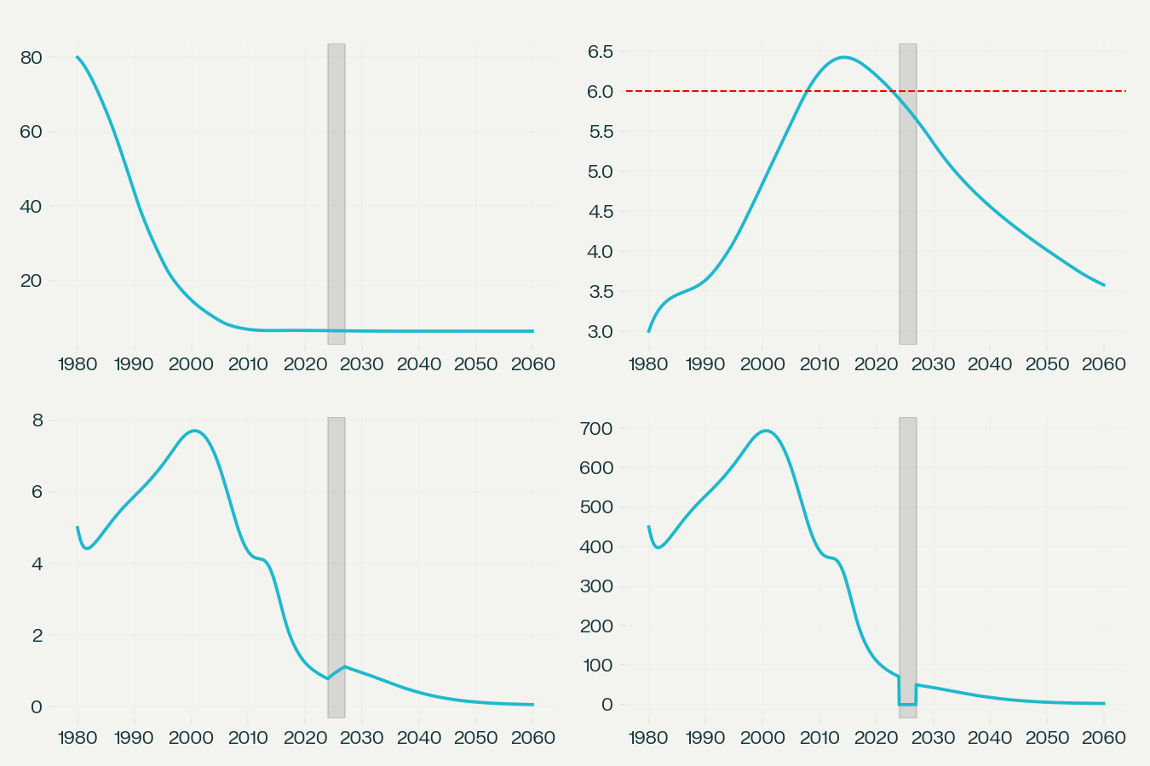
Figure 1. Baseline run (grey band: fishing ban; red line: 6 mg/L oxygen threshold).

5. Scenarios
Scenario | Adults 2025 | Adults 2040 | Adults 2059 | O2 2059 | Catch 2059 (t)
Baseline | 0.92 | 0.40 | 0.06 | 3.6 | 3
No stickleback | 5.34 | 4.56 | 2.38 | 3.6 | 107
No further warming | 1.55 | 2.23 | 2.22 | 8.7 | 100
Neither | 5.31 | 4.70 | 5.80 | 8.7 | 261
Agri P x3 | 0.73 | 0.07 | 0.04 | 1.0 | 2
Fishing 0.3 after 2027 | 0.92 | 0.14 | 0.04 | 3.6 | 3

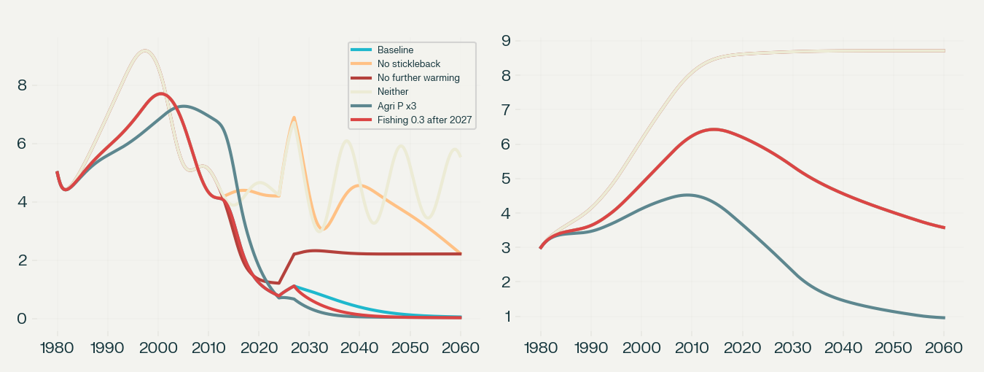
Figure 2. Scenario comparison.
Warming and stickleback are each sufficient to cause a large decline; together they are near-fatal for the natural population, which then survives only through stocking. Tripling agricultural P (about 14 ug/L) drives deep O2 to about 1 mg/L and triggers sediment P release. Relaxing fishing after 2027 has a small absolute effect because the stock is already low, but speeds the decline.

6. Limitations and next steps
Not calibrated to your series: the embedded charts in the data document could not be read, so the model was tuned to published point values. Assumed parameters: temperature-effect table, stickleback effects, egg and larval survival, Beverton-Holt capacity, adult weight, agriculture/wastewater P split, zooplankton scale, fishing fraction, stocking history (120 million/yr until 2017, 20 million after).
Structural simplifications: no seasonality; deterministic circulation; one species and two stages; nitrogen and chloride not used; quagga mussels omitted.
- Import temperature, O2, P and catch series as lookups and compare with model output.
- Calibrate on catch and O2 after fixing P, temperature and O2 drivers.
- Add the 2025 age structure to split adults into age classes.
- Run Monte Carlo sensitivity on the temperature table and stickleback parameters.
- Test the egg phosphorus-content relationship from the BAFU report.

Sources
IGKB fact sheets on phosphorus and circulation (igkb.org); IGKB basic parameters; BAFU fact sheet on Lake Constance water quality; Aqua & Gas 2023 'Fischbestaende des Bodensees' (Rey et al.); LAZBW Fischarteninventar Bodensee; Universitaet Konstanz (2025); Schwaebische Zeitung, 9 Oct 2026; Radio Central, 20 Oct 2026; the user's Data-CO1 document and sketch.

